**We’ve Upgraded Nassau! Better, Faster, Stronger!**

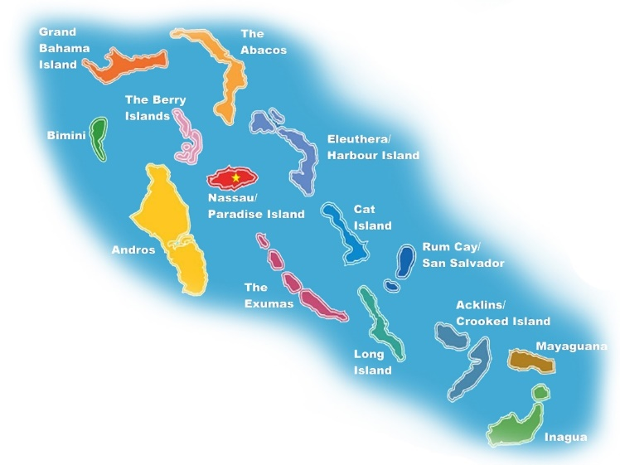 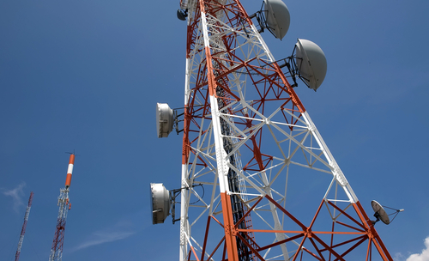

**Visit us at www.BahamasWiMax.com**

We are pleased to announce the launch of our upgraded internet services in Nassau,

**Effective May 1st, 2021**

**Get Started**

To get started email us at sales@bahamaswimax.com or contact our Nassau sales rep at 242-829-9008 or call 242-577-0462 to take advantage of these specials.

Service is now available in select areas.

We have deployed the latest state of the art hardware to bring you the fastest and most reliable service in the market! You will have:

* **Consistent UP and DOWN SPEED to 20 Mbps.**
* **Unlimited usage with NO CAPS on your data downloads!**

As part of our Nassau upgrade campaign, we are offering the following specials through **August 31, 2021**:

* **FREE service category upgrade for three months on all new purchases.**
* **Purchase a 14, 18 or 20 Mbps package and receive a 10% discount on installation!**
* **Pay for 6 months or more in advance and receive an additional 10% discount off your monthly rate.**

**New State of the Art Network**

SIGN UP TODAY

**Nassau Special !**